Probability & Statistics
Project On
Impact of COVID-19 Outbreak on Global Air Quality
A Project Submitted
in Partial Fulfillment of the Requirements for the
Degree of Bachelor of Technology
In CSE
SUBMITTED BY: GROUP NO: 6
Group Members:
Yug Saini - 240706
Utkarsh Faujdar - 240950

SCHOOL OF ENGINEERING AND TECHNOLOGY
BML MUNJAL UNIVERSITY GURGAON
May 2025

Table of Contents

Problem statement

Introduction

Materials and Method

Results and discussions

Conclusion

Acknowledgement

Reference

Problem Statement: -

The COVID-19 pandemic led to widespread lockdown across the world and in turn caused a significant reduction in usage of motor vehicles and industries. This study explores the statistical approach towards “Impact of COVID-19 Outbreak on Global Air Quality”. We will be particularly focusing on PM2.5, PM10, SO₂, NO₂, CO, and O₃ since it is the most harmful one. The aim is to analyze and compare air quality data before and after the COVID-19 lockdown to determine the impact of reduced industrial and transportation activities on atmospheric pollution levels. This will help us reflect on how human activities directly affect the environment we live in.

Introduction: -
Air pollution is contamination of the environment by chemical, biological or physical agents that interferes with the natural integrity / characteristics of the atmosphere. Pollutants of major public health concerns include particulate matter(pm), carbon monoxide, ozone, nitrogen dioxide and sulfur dioxide. Particulate matter are microscopic particles of solid and liquid that are suspended in the air. Some of these particles, particularly pm2.5 and pm10 are considered dangerous as they can enter deeply into the respiratory tract and cause lung irritation though the air we breathe through our nose. Carbon monoxides (CO) are emitted as a result of incomplete combustion of fossil fuels (forms of patrols, diesels and coal), this pollutant can enter the human body through our nose and bind to hemoglobin present in our blood to form a complex which is more stable than the complex formed with oxygen, therefore blocking the supply of oxygen to our cells. Ozone (O3) is formed when sunlight reacts with nitrogen oxides (NO3) and volatile organic compounds (VOCs). Ozone is a major component of smog (smoke+fog). It is linked to many respiratory issues like asthma and bronchitis. Nitrogen dioxide and Sulfur dioxide are both linked to causing issues like shortness of breath, lung irritation, and major diseases like asthma. Moreover, high content of SO2 and NO2 in the air can cause acid rain which is very harmful for plants and animals.
This whole ‘Air Pollution’ topic is now-adays very talked upon because of the un-bothered and selfish approach of humans towards their development, thereby totally undermining the effects of their certain actions that has led harsh effects on other species living on the Earth.
In 2019 Q4, the Air Quality Index (AQI) in many major cities was at a peak. Pollution levels, particularly for PM2.5 and PM10, were alarmingly high, largely due to unregulated industrial activity, high traffic emissions, and the onset of winter in many regions which typically worsens air quality. Gases like SO₂, NO₂, CO, and O₃ were also found in elevated concentrations, reflecting the heavy dependence on fossil fuels and lack of stringent air quality enforcement.
However, as the world entered 2020, a sharp shift occurred. The outbreak of COVID-19 led to global lockdowns, starting in Q1 and intensifying through Q2. During this period, the use of vehicles drastically reduced, factories shut down, and public transport came to a halt in several countries. As a result, there should be a noticeable dip in the levels of harmful pollutants. This therefore will study analyze the Impact of COVID-19 Outbreak on Global Air Quality.

Material And Methods: -
To analyze the impact of the COVID-19 outbreak on global air quality, air pollutant data was collected from the World Air Quality Index (WAQI) datasets. The datasets included mean, median and variance measurements of key pollutants from major cities across the world for the following time periods:
2019 Q4 (pre-COVID phase – baseline for comparison)
2020 Q1 and Q2 (During strict lockdown phases)
2020 Q3 (Gradual reopening phase)
Pollutants Analyzed:
Our focus is on six major air pollutants due to their widespread health impact as discussed in the previous section:
PM2.5 (Particulate Matter ≤ 2.5μm)
PM10 (Particulate Matter ≤ 10μm)
SO₂ (Sulfur Dioxide)
NO₂ (Nitrogen Dioxide)
CO (Carbon Monoxide)
O₃ (Ozone)
Data Cleaning and Preprocessing:
All CSV files were cleaned by removing metadata rows and filtering out corrupted or commented entries. Non-date rows and missing or invalid entries were dropped. Dates were standardized using Python’s pandas library for accurate grouping and analysis. We extracted median values of each pollutant from each city and stored them in a variable for both pre-covid (2019 Q4) and post covid (2020 Q3). For statistical validation, two-sample t-tests were performed between the 2019 Q4 (pre-COVID) data and the combined 2020 Q1, Q2, and Q3 data for each pollutant. The t-test is a statistical method used to determine whether there is a significant difference between the means of two groups. In this study, the two groups were medians of:
Group 1: Pollution levels in 2019 Q4 (before the COVID-19 outbreak).
Group 2: Pollution levels in 2020 Q3 (after the initial COVID-19 lockdowns).
For each pollutant (PM2.5, PM10, SO₂, NO₂, CO, O₃), the t-test compared the average concentration levels of the medians between these two time periods. It asked:
“Are the observed differences in pollution levels due to random chance, or are they statistically significant?”
If the p-value returned by the t-test was less than 0.05, it meant the difference was statistically significant — i.e., there's strong evidence (95% confidence) that pollution levels changed due to real-world factors (like lockdowns), not just by random fluctuations.
Therefore ,the t-test helped confirm whether the observed changes in air quality before and during COVID-19 were real and meaningful, not accidental.
This was done using the scipy.stats module, and a p-value less than 0.05 was used to indicate statistical significance. Additionally, visualizations were created using matplotlib to graphically represent the changes in pollutant concentrations across the time periods. This approach provided both a statistical and visual understanding of how lockdown measures may have affected global air quality.
Code: This Code is also available on my GitHub
import pandas as pd
import numpy as np
import matplotlib.pyplot as plt
from scipy import stats

df_2019_q4 = pd.read_csv('data2019_Q4.csv', skiprows=4)
df_2020_q3 = pd.read_csv('data2020_Q3.csv', skiprows=4)
def clean_air_data(df):
df = df[~df['Date'].astype(str).str.contains('#', na=False)]
df['Date'] = pd.to_datetime(df['Date'], errors='coerce')
df = df.dropna(subset=['Date'])
return df

df_2019_q4 = clean_air_data(df_2019_q4)
df_2020_q3 = clean_air_data(df_2020_q3)
# Combine 2020 data to represent "after COVID" period
df_post_covid = df_2020_q3
# Geting unique pollutant species names
pollutants = sorted(df_2019_q4['Specie'].unique())

# Store t-test results
results = []
pollutants = ['pm25', 'pm10','so2','no2','co','o3']

# Perform t-test for pm2.5 and pm10 pollutants
for pollutant in pollutants:
# Perform t-test for each pollutant, excluding AQI
# Get pre-COVID data for this pollutant
pre_covid = df_2019_q4[df_2019_q4['Specie'] == pollutant]['median'].dropna()

# Get during-COVID data for this pollutant
post_covid = df_post_covid[df_post_covid['Specie'] == pollutant]['median'].dropna()

# Perform t-test
t_stat, p_value = stats.ttest_ind(pre_covid, post_covid, equal_var=False)

# Calculate means of medians
pre_mean = pre_covid.mean()
post_mean = post_covid.mean()
percent_change = ((post_mean - pre_mean) / pre_mean) * 100

# Store results
results.append({
'Pollutant': pollutant,
'Pre-COVID Mean': round(pre_mean, 2),
'Post-COVID Mean': round(post_mean, 2),
'Percent Change': round(percent_change, 2),
'p-value': round(p_value, 4),
'Significant': p_value < 0.05
})

# Convert results to DataFrame for easier display
results_df = pd.DataFrame(results)
print("T-Test Results:")
print(results_df)

# Plot the results for significant changes
significant_results = results_df[results_df['Significant']]

if not significant_results.empty:
plt.figure(figsize=(10, 6))

# Prepare data for plotting
pollutants = significant_results['Pollutant']
pre_means = significant_results['Pre-COVID Mean']
post_means = significant_results['Post-COVID Mean']

# Set up bar positions
x = np.arange(len(pollutants))
width = 0.35

# Create bars
plt.bar(x - width/2, pre_means, width, label='Pre-COVID (2019 Q4)')
plt.bar(x + width/2, post_means, width, label='After COVID (2020 Q3)')

# Add labels and title
plt.xlabel('Pollutants')
plt.ylabel('Median Concentration')
plt.title('Significant Changes in Air Quality Due to COVID-19')
plt.xticks(x, pollutants)
plt.legend()

# this code displays the arrow and amount of decrease percentage wise
for i, pollutant in enumerate(pollutants):
percent = significant_results[significant_results['Pollutant'] == pollutant]['Percent Change'].values[0]
direction = "↓" if percent < 0 else "↑"
plt.annotate(f"{abs(percent):.1f}% {direction}",
xy=(i, max(pre_means[i], post_means[i]) + 1),
ha='center')
plt.tight_layout()
plt.show()
else:
print("No statistically significant changes were found.")

Results and Discussion: -
The comparative analysis between air quality data from 2019 Q4 (pre-COVID) and 2020 Q3 (post initial lockdowns) revealed a notable decline in several key air pollutants. Using a two-sample t-test on the mean of medians of ppm (parts per million) values of pollutants across cities, we found that PM2.5 decreased by 26.4%, PM10 by 24.4%, SO₂ by 20.5%, NO₂ by 39.2%, and CO by 19.4%. These declines suggest a significant improvement in air quality during the early phase of the pandemic, likely due to reduced transportation, industrial activity, and energy consumption.
Interestingly, O₃ (ozone) was the only pollutant that increased, by 34.9%. This rise is consistent with what many global studies observed, ozone levels can increase when nitrogen oxides (NOx) decrease, due to reduced titration in urban environments. This shift underscores the complex atmospheric chemistry governing air pollution.
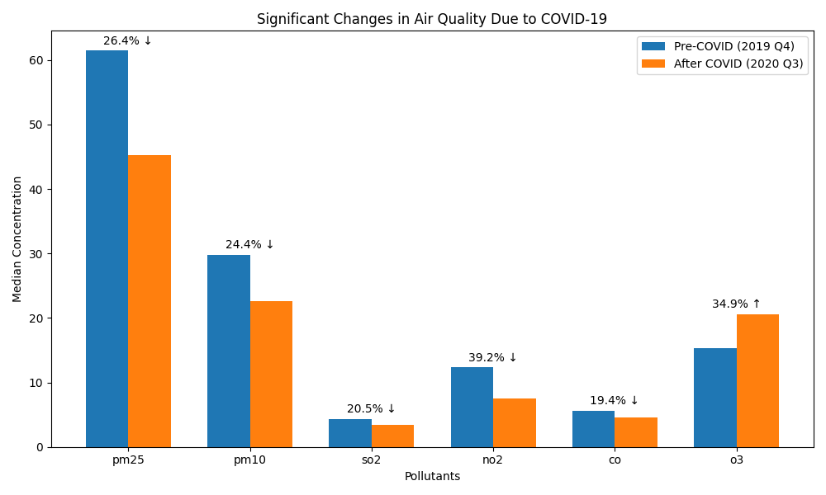
The t-test p-values for all pollutants were less than 0.05, indicating that these changes are statistically significant and unlikely to be the result of random chance and therefore were the impact of imposed lockdowns due to COVID-19. The analysis confirms that the COVID-19 pandemic, while devastating in many ways, offered a rare global-scale experiment in emissions reduction and its immediate impact on air quality.

Conclusion: -

The COVID-19 pandemic created a unique situation that significantly reduced human activity and emissions worldwide. This study analyzed air quality data from pre-COVID (2019 Q4) and during-COVID (2020 Q1–Q3) periods to assess changes in key pollutants: PM2.5, PM10, SO₂, NO₂, CO, and O₃. Using statistical techniques, particularly the independent two-sample t-test, we evaluated whether the observed differences were statistically significant. All these pollutants are primarily emitted by vehicles, industries, and power plants, which were largely inactive during the lockdown periods. When lockdowns happened and these activities stopped or slowed down, the pollution levels dropped, and the numbers clearly show that. This shows a direct relationship between human activities and air pollution.
From the point of view of our Probability and Statistics course, this project helped us apply what we learned in class to a real-world topic. We worked with large datasets, cleaned the data, calculated medians and means, and applied a t-test to compare two different time periods. We also learned how to interpret p-values and what it means when we say a result is "statistically significant."
In short, this project showed that statistical tools are powerful in helping us understand real-world problems. The results clearly showed that air pollution decreased during the COVID-19 lockdowns, proving that human actions have a big impact on the environment. These findings can be useful for governments and environmental planners who are looking for ways to reduce pollution and improve public health.
By using statistics, we didn’t just make guesses, we backed up our observations with strong evidence. This kind of approach is important in science and policymaking, and it also shows the usefulness of statistics in everyday life.

Acknowledgement: -
We would like to express our sincere gratitude to all those who supported us during the course of this project.
Firstly, we would like to thank our project supervisor Dr. Palak Goel, whose valuable guidance, insights, and constant encouragement helped us stay focused and motivated throughout the project. Her expertise has been instrumental in shaping the direction of our project.
We are grateful to the faculty members of BMU, whose teachings have provided a solid foundation for this project, especially in areas of data science, analyses, and mathematics.
Additionally, we would like to acknowledge all the team members for their collaborative spirit and teamwork, making this project an enjoyable and fulfilling experience.
Lastly, we would like to thank the developers and contributors of the open-source libraries and resources we used in this project. Their work made it possible to implement and improve the decision tree model and data analysis, and we are deeply appreciative of their efforts.
Thank you to all who have supported us throughout this project.

Reference: -
- NumPy
Reference:
Harris, C. R., Millman, K. J., van der Walt, S. J., Gommers, R., Taylor, J. P., & the NumPy community. (2020). Array programming with NumPy. Nature, 585(7825), 357–362. https://doi.org/10.1038/s41586-020-2649-2
- Pandas
Reference:
McKinney, W. (2010). Data structures for statistical computing in Python. Proceedings of the 9th Python in Science Conference, 51-56. https://doi.org/10.5281/zenodo.3509134
- Matplotlib
Reference:
Hunter, J. D. (2007). Matplotlib: A 2D graphics environment. Computing in Science & Engineering, 9(3), 90-95. https://doi.org/10.1109/MCSE.2007.55
- Virtanen, P., et al. (2020). SciPy 1.0: Fundamental Algorithms for Scientific Computing in Python. Nature Methods, 17, 261–272. https://doi.org/10.1038/s41592-019-0686-2
- Ronald E. Walpole, Sharon L. Myers and Keying Ye, Probability and Statistics for Engineers and Scientists, ISBN: 978-93-325-1908-4, 9th Edition, Pearson, 2016.

